DATA STRUCTURES AND ALGORITHMS LAB
(Course Code: 23UPCSC1L04)

A programming laboratory record submitted to Periyar University, Salem In partial fulfillment of the requirements for the degree of

MASTER OF COMPUTER APPLICATIONS

By

HARI GAYATHIRI M

[Reg. No: U24PG507CAP007]



DEPARTMENT OF COMPUTER SCIENCE PERIYAR UNIVERSITY
(NAAC `A++` Grade with CGPA 3.61) – NIRF RANK 56 – ARIIA RANK 10 PERIYAR PALKALAI NAGAR,
SALEM – 636 011.
(APRIL - 2025)

CERTIFICATE

This is to certify that the Programming Laboratory entitled
“DATA STRUCTURE AND ALGORITHMS LAB (23UPCSC1L04)” is a
bonafide record work done by Mr. /Ms. Register No: as partial fulfillment of the requirements for the degree of Master of Computer Applications, in the Department of Computer Science, Periyar University, Salem, during the Academic Year 2024-2025.

Staff In-charge Head of the Department

Submitted for the practical examination held on……...………………

Internal Examiner External Examiner

CONTENTS
S.NO | DATE | TITLE OF THE PROGRAM | PAGE NO | SIGNATURE
1. |  | Recursion concepts  - Linear recursion  - Binary recursion
2. |  | Stack ADT
3. |  | Queue ADT
4. |  | Doubly Linked List ADT
5. |  | Heaps using Priority Queues
6. |  | Merge sort
7. |  | Quick sort
8. |  | Binary Search Tree
9. |  | Minimum Spanning Tree
10. |  | Depth First Search Tree Traversal

SOURCE CODE:

import pandas as pd
import random

# Generate random data
dataset={
"Marital_status": random.choices(["Yes","No"], k=600),
"Is_graduate": random.choices(["Yes","No"], k=600),
"Income":[random.randint(20000,1000000) for _ in range(600)],
"Loan_amount":[random.randint(1000,50000) for _ in range(600)],
"Term_months": random.choices([12, 24, 36, 48, 60], k=600),
"Age":[random.randint(20,60) for _ in range(600)],
"Sex": random.choices(["F","M"], k=600),
"Approval_status": random.choices(["Yes","No"], k=600)
}

# Create a DataFrame from the generated data
data=pd.DataFrame(dataset)

# Save the dataset to a CSV file
data.to_csv("dataset.csv", index=False)

print("Mean:",round(data['Income'].mean(),3))
print("Median:",data['Income'].median())
print("Standard Deviation:",data['Income'].std())
print("Variance:",data['Income'].var())
print("Mode:",data['Income'].mode()[0])

OUTPUT:

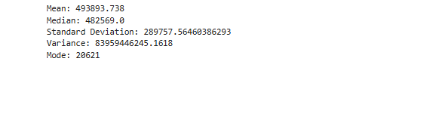

SOURCE CODE:

import pandas as pd
import numpy as np
from sklearn.model_selection import train_test_split
from sklearn.linear_model import LinearRegression
from sklearn.metrics import r2_score, mean_squared_error
import matplotlib.pyplot as plt

dataset=pd.read_csv("https://raw.githubusercontent.com/selva86/datasets/master/
BostonHousing.csv")
dataset.info()
dataset

X=dataset.drop('medv',axis=1)
y=dataset['medv']
x=X[['age']]

#Single Linear Regression Program
x_train, x_test, y_train, y_test=train_test_split(x, y, test_size=0.2, random_state=10)

lr=LinearRegression()
lr.fit(x_train, y_train)
result=lr.predict(x_test)
mse=mean_squared_error(y_test, result)
rmse=np.sqrt(mse)
r2=r2_score(y_test, result)

print(f"Mean Squared Error: {mse:.2f}")
print(f"Root Mean Squared Error: {rmse:.2f}")
print(f"R-Sqared: {r2:.2f}")

plt.scatter(y_test, result)
plt.plot([min(y_test), max(y_test)], [min(y_test), max(y_test)], linestyle='--', color='red')
plt.xlabel('Actual Values')
plt.ylabel('Predicted Values')
plt.title('Regression Line')
plt.show()

#Multi Linear Regression Program
x_train, x_test, y_train, y_test=train_test_split(X,y,test_size=0.2, random_state=10)
lr=LinearRegression()
lr.fit(x_train, y_train)
result1=lr.predict(x_test)

mse=mean_squared_error(y_test, result1)
rmse=np.sqrt(mse)
r2=r2_score(y_test, result1)

print(f"Mean Squared Error: {mse:.2f}")
print(f"Root Mean Squared Error: {rmse:.2f}")
print(f"R-Sqared: {r2:.2f}")

plt.scatter(y_test, result1)
plt.plot([min(y_test), max(y_test)], [min(y_test), max(y_test)], linestyle='-', color='red')
plt.xlabel('Actual Values')
plt.ylabel('Predicted Values')
plt.title('Regression Line')
plt.show()
OUTPUT:

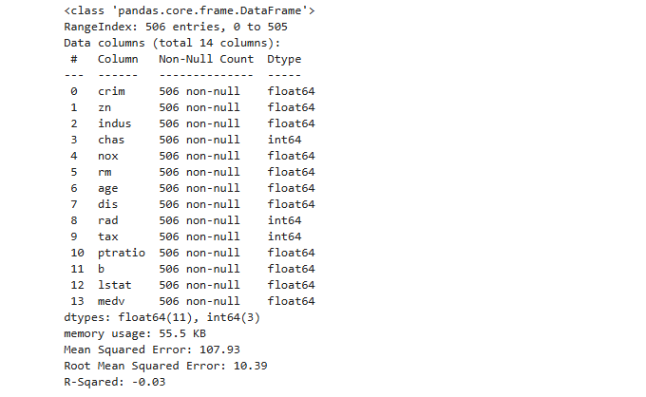

Single Linear Regression Program:
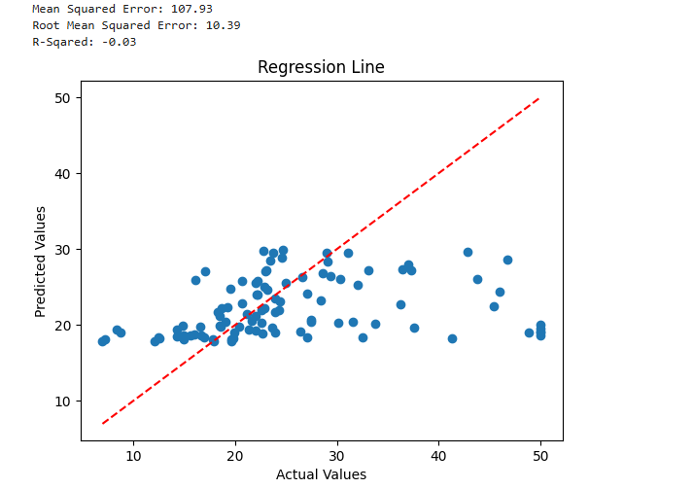

Mulitple Linear Regression Program:

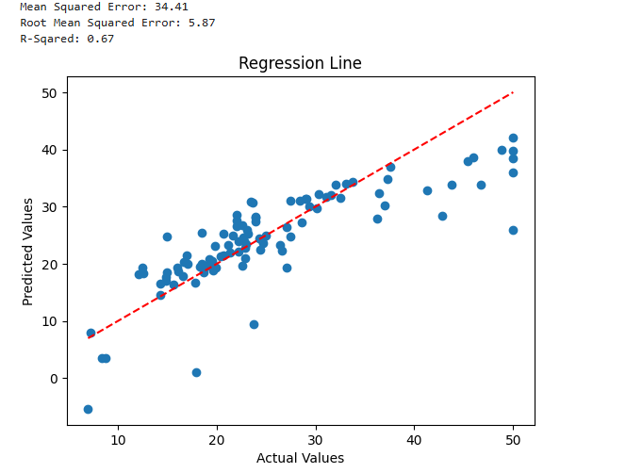

SOURCE CODE:

import pandas as pd
import matplotlib.pyplot as plt

df=pd.read_csv(r"C:\Users\Welcome\Desktop \insurance_data.csv")
df.head()
plt.scatter(df.age, df.bought_insurance, marker='+', color='red')
plt.show()

from sklearn.model_selection import train_test_split
from sklearn.linear_model import LogisticRegression

x_trian, x_test, y_trian, y_test=train_test_split(df[['age']], df.bought_insurance, train_size=0.8)
model=LogisticRegression()
model.fit(x_train, y_train)
y_predicted=model.predict(x_test)
model.predict_proba(x_test)
model.score(x_test, y_test)

from sklearn.metrics import classification_report

classification_rep=classification_report(y_test, y_predicted)
print(classification_rep)

OUTPUT:

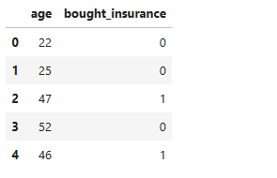
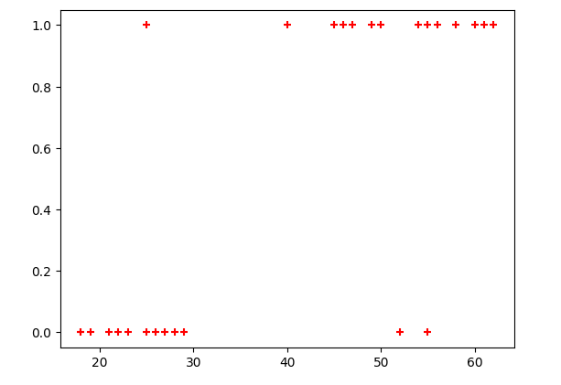

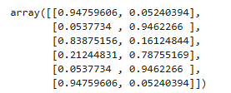
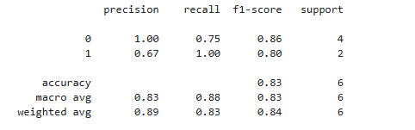

SOURCE CODE:

class Queue:
def init (self): self.items = []

def enqueue(self, item): self.items.append(item)

def dequeue(self):
if not self.is_empty(): return self.items.pop(0)
else:
print("Queue is empty.") return None

def is_empty(self):
return len(self.items) == 0

def size(self):
return len(self.items)

def front(self):
if not self.is_empty(): return self.items[0]
else:
print("Queue is empty.") return None

def rear(self):
if not self.is_empty(): return self.items[-1]
else:

print("Queue is empty.") return None

def display(self): print("Queue:", self.items)

def main():
queue = Queue()

print("\nMenu:")
print("1. Enqueue element") print("2. Dequeue element")
print("3. Check if the queue is empty") print("4. Display queue size")
print("5. Display front element") print("6. Display rear element") print("7. Display queue") print("8. Exit")

while True:
choice = int(input("Enter your choice: "))

if choice == 1:
item = input("Enter the element to enqueue: ") queue.enqueue(item)
print(f"{item} enqueued.") elif choice == 2:
dequeued_item = queue.dequeue() if dequeued_item is not None:
print(f"{dequeued_item} dequeued.") elif choice == 3:
print("Is the queue empty?", queue.is_empty())

elif choice == 4:
print("Queue size:", queue.size()) elif choice == 5:
front_element = queue.front() if front_element is not None:
print("Front element:", front_element) elif choice == 6:
rear_element = queue.rear() if rear_element is not None:
print("Rear element:", rear_element) elif choice == 7:
queue.display() elif choice == 8:
print("Exiting the program.") break
else:
print("Invalid choice. Please enter a valid option.")

if name == ' main ': main()

OUTPUT:

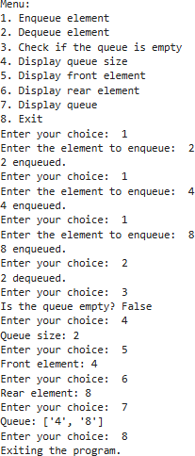

SOURCE CODE:
import os class _Node:
slots = '_element', '_link', '_prev'

def init (self, element, link, prev): self._element = element
self._link = link self._prev = prev

class DoublyLL:
def init (self): self._head = None self._tail = None self._size = 0

def len (self): return self._size

def isempty(self): return self._size == 0

def addLast(self, e):
newest = _Node(e, None, None) if self.isempty():
self._head = newest else:
self._tail._link = newest newest._prev = self._tail
self._tail = newest self._size += 1

def addFirst(self, e):
newest = _Node(e, None, None) if self.isempty():
self._head = newest self._tail = newest
else:
newest._link = self._head self._head._prev = newest self._head = newest
self._size += 1

def addAnywhere(self, e, index): if index > self._size:
print(f'Index value out of range, it should be between 0 -
{self._size}')
elif index == self._size: self.addLast(e)
elif index == 0: self.addFirst(e)
else:
newest = _Node(e, None, None) p = self._head
for _ in range(index - 1): p = p._link
newest._link = p._link p._link._prev = newest newest._prev = p p._link = newest self._size += 1

def removeFirst(self): if self.isempty():

print('List is already empty') return
e = self._head._element self._head = self._head._link self._size -= 1
if self.isempty(): self._tail = None
else:
self._head._prev = None return e

def removeLast(self): if self.isempty():
print("List is already empty") return
e = self._tail._element self._tail = self._tail._prev self._size -= 1
if self.isempty(): self._head = None
else:
self._tail._link = None return e

def removeAnywhere(self, index): if index >= self._size:
print(f'Index value out of range, it should be between 0 -
{self._size - 1}')
elif self.isempty(): print("List is empty")
elif index == 0:
return self.removeFirst() elif index == self._size - 1:

return self.removeLast() else:
p = self._head
for _ in range(index - 1): p = p._link
e = p._link._element p._link = p._link._link p._link._prev = p self._size -= 1
return e

def display(self):
if self.isempty(): print("List is Empty") return
p = self._head print("NULL<-->", end='') while p:
print(p._element, end="<-->") p = p._link
print("NULL")
print(f"\nHead : {self._head._element}, Tail :
{self._tail._element}")

def options():
options_list = ['Add Last', 'Add First', 'Add Anywhere', 'Remove First', 'Remove Last', 'Remove Anywhere', 'Display List', 'Exit']
print("MENU")
for i, option in enumerate(options_list): print(f'{i + 1}. {option}')
choice = int(input("Enter choice: ")) return choice

def switch_case(choice): os.system('cls')
if choice == 1:
elem = int(input("Enter Item: ")) DL.addLast(elem)
print("Added Item at Last!\n\n") elif choice == 2:
elem = int(input("Enter Item: ")) DL.addFirst(elem)
print("Added Item at First!\n\n") elif choice == 3:
elem = int(input("Enter Item: ")) index = int(input("Enter Index: ")) DL.addAnywhere(elem, index)
elif choice == 4:
print("Removed Element from First:", DL.removeFirst()) elif choice == 5:
print("Removed Element from last:", DL.removeLast()) elif choice == 6:
index = int(input("Enter Index: "))
print(f"Removed Item: {DL.removeAnywhere(index)} !\n\n") elif choice == 7:
print("List:") DL.display() print("\n")
elif choice == 8: import sys sys.exit()

if name == ' main ': DL = DoublyLL()
while True: try:

choice = options() switch_case(choice)
except SystemExit: print("Exiting the program.") break

OUTPUT:

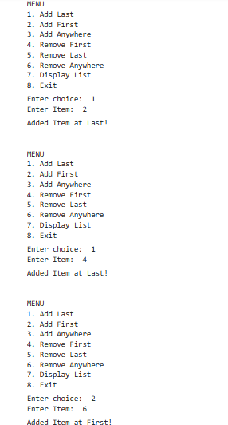

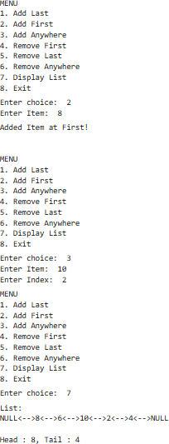

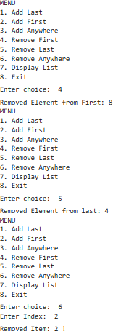

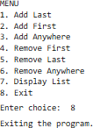

SOURCE CODE:
import heapq class MaxHeap:
def init (self): self._heap = []

def insert(self,item): heapq.heappush(self._heap,-item)

def delete(self):
if len(self._heap) > 0:
return -heapq.heappop(self._heap) else:
raise Exception("Heap is Empty")

def peek(self):
if len(self._heap) > 0: return self._heap[0]
else:
raise Exception("Heap is Empty")

def size(self):
return len(self._heap)

class PriorityQueue: def init (self):
self._heap = MaxHeap()

def push(self,item,priority): self._heap.insert(priority)

def pop(self):
if self.is_empty():
raise IndexError("Pop from an empty priority queue") return self._heap.delete()
def is_empty(self):
return self._heap.size() == 0 pq = PriorityQueue()
print("\nMENU")
print("1.Add task and priority") print("2.Remove task with highest priority") print("3.Exit")
while True:
choice = input("Enter your choice:") if choice == '1':
task = input("Enter the task:")
priority = int(input("Enter the priority:")) pq.push(task, priority)
print(f"Task '{task}' with priority {priority} added to the priority
queue")
elif choice == '2': try:
removed_task = pq.pop()
print(f"Task: '{removed_task}' with highest priority removed from the priority queue")
except IndexError:
print("Priority queue is empty cannot remove task") elif choice == '3':
print("Exiting the program") break
else:
print("Invalid choice. Please enter the valid option.")

OUTPUT:

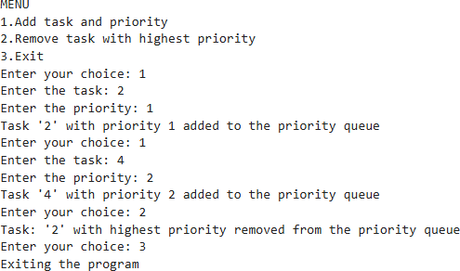

SOURCE CODE:

def merge_sort(arr): if len(arr) <= 1: return arr
mid = len(arr)//2 left = arr[:mid] right = arr[mid:]
left = merge_sort(left) right = merge_sort(right) return merge(left,right)

def merge(left,right): result = []
i,j = 0,0
while i < len(left) and j < len(right): if left[i] < right[j]:
result.append(left[i]) i+=1
else:
result.append(right[j]) j+=1
result+=left[i:] result+=right[j:] return result

user_input=input("Enter the list of numbers separated by spaces:") arr=[int(num) for num in user_input.split()] sorted_arr=merge_sort(arr)
print("Input Array:",arr) print("Sorted Array:",sorted_arr)

OUTPUT:

SOURCE CODE:

def quick_sort(alist,start,end): if end-start>1:
p = partition(alist,start,end) quick_sort(alist,start,p) quick_sort(alist,p+1,end)

def partition(alist,start,end): pivot = alist[start]
i = start+1
j = end-1 while True:
while i<=j and alist[i]<=pivot: i=i+1
while i<=j and alist[j]>=pivot: j=j-1
if i<=j:
alist[i],alist[j]=alist[j],alist[i] else:
alist[start],alist[j]=alist[j],alist[start] return j

alist=input("Enter the list of numbers:").split() alist=[int(x) for x in alist]
quick_sort(alist ,0 ,len(alist) - 1) print("Sorted List:",alist)

OUTPUT:

SOURCE CODE:

class binarySearchTree:
def init (self, val=None): self.val = val
self.left = None self.right = None

def insert(self, val): if self.val is None:
self.val = val else:
if val == self.val:
return 'No duplicates allowed in the binary search tree' if val < self.val:
if self.left: self.left.insert(val)
else:
self.left = binarySearchTree(val)
else:
if self.right: self.right.insert(val)
else:
self.right = binarySearchTree(val)

def breadthFirstSearch(self): currentNode = self bfs_list = []
queue = []
queue.insert(0, currentNode) while len(queue) > 0:
currentNode = queue.pop() bfs_list.append(currentNode.val)

if currentNode.left:
queue.insert(0, currentNode.left) if currentNode.right:
queue.insert(0, currentNode.right) return bfs_list

def depthFirstSearch_INorder(self): return self.traverseInOrder([])

def depthFirstSearch_PREorder(self): return self.traversePreOrder([])

def depthFirstSearch_POSTorder(self): return self.traversePostOrder([])

def traverseInOrder(self, lst): if self.left:
self.left.traverseInOrder(lst) lst.append(self.val)
if self.right: self.right.traverseInOrder(lst)
return lst

def traversePreOrder(self, lst): lst.append(self.val)
if self.left: self.left.traversePreOrder(lst)
if self.right: self.right.traversePreOrder(lst)
return lst

def traversePostOrder(self, lst): if self.left:

self.left.traversePostOrder(lst) if self.right:
self.right.traversePostOrder(lst) lst.append(self.val)
return lst

def findNodeAndItsParent(self, val, parent=None): if val == self.val:
return self, parent if val < self.val:
if self.left:
return self.left.findNodeAndItsParent(val, self) else:
return 'Not found'
else:
if self.right:
return self.right.findNodeAndItsParent(val, self) else:
return 'Not found'

def delete(self, val):
if self.findNodeAndItsParent(val) == 'Not found': return 'Node is not in tree'

deleting_node, parent_node = self.findNodeAndItsParent(val) nodes_effected = deleting_node.traversePreOrder([])

if len(nodes_effected) == 1: if parent_node is not None:
if parent_node.left == deleting_node: parent_node.left = None
else:
parent_node.right = None

else:
self.val = None self.left = None self.right = None
else:
if parent_node is None: nodes_effected.remove(deleting_node.val) self.left = None
self.right = None self.val = None
for node in nodes_effected: self.insert(node)
else:
nodes_effected.remove(deleting_node.val) if parent_node.left == deleting_node:
parent_node.left = None else:
parent_node.right = None

if parent_node is not None: nodes_effected.remove(parent_node.val)

for node in nodes_effected: self.insert(node)

return 'Successfully deleted'

# Example usage with user input: bst = binarySearchTree()

while True: print("\nMENU:") print("1. Insert Element")

print("2. Breadth-First Search")
print("3. Depth-First Search (In-Order)") print("4. Depth-First Search (Pre-Order)") print("5. Depth-First Search (Post-Order)") print("6. Delete Node")
print("7. Exit")
choice = input("Enter your choice: ") if choice == "1":
element = int(input("Enter the element to insert: "))
print(bst.insert(element)) elif choice == "2":
print("Breadth-First Search:", bst.breadthFirstSearch()) elif choice == "3":
print("Depth-First Search (In-Order):", bst.depthFirstSearch_INorder())
elif choice == "4":
print("Depth-First Search (Pre-Order):", bst.depthFirstSearch_PREorder())
elif choice == "5":
print("Depth-First Search (Post-Order):", bst.depthFirstSearch_POSTorder())
elif choice == "6":
node_to_delete = int(input("Enter the node value to delete: ")) print(bst.delete(node_to_delete))
elif choice == "7": print("Exiting the program.") break
else:
print("Invalid choice. Please enter a valid option.")

OUTPUT:

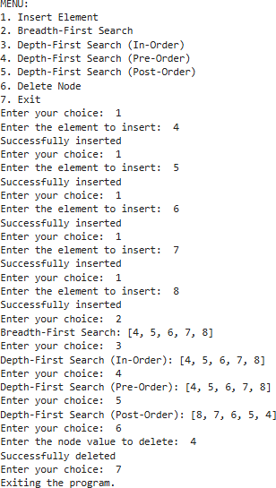

SOURCE CODE (Prim’s Algorithm) :
import heapq class Graph:
def init (self, vertices):
self.V = vertices # Number of vertices self.graph = {i: [] for i in range(vertices)}

def add_edge(self, u, v, w): self.graph[u].append((w, v))
self.graph[v].append((w, u))

def prim_mst(self): min_heap = [(0, 0)] visited = set()
mst = [] total_weight = 0

while len(visited) < self.V:
weight, u = heapq.heappop(min_heap) if u in visited:
continue visited.add(u) total_weight += weight

if len(visited) > 1: mst.append((u, weight))

for w, v in self.graph[u]: if v not in visited:
heapq.heappush(min_heap, (w, v))

print("Edges in the Minimum Spanning Tree:") for u, w in mst:
print(f"{u} -- {w}")
print(f"Total weight of MST: {total_weight}")

vertices = int(input("Enter number of vertices: ")) edges = int(input("Enter number of edges: "))
g = Graph(vertices)

print("Enter the edges (u v w):") for _ in range(edges):
u, v, w = map(int, input().split()) g.add_edge(u, v, w)

g.prim_mst()

OUTPUT (Prim’s Algorithm):

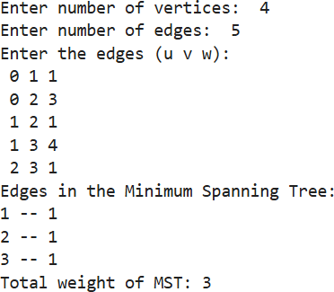

SOURCE CODE (Kruskal’s Algorithm):

class Graph:
def init (self, vertices): self.V = vertices self.graph = []

def add_edge(self, u, v, w): self.graph.append([u, v, w])

def find(self, parent, i): if parent[i] == i:
return i
return self.find(parent, parent[i])

def union(self, parent, rank, x, y): root_x = self.find(parent, x) root_y = self.find(parent, y)
if rank[root_x] < rank[root_y]: parent[root_x] = root_y
elif rank[root_x] > rank[root_y]: parent[root_y] = root_x
else:
parent[root_y] = root_x rank[root_x] += 1

def kruskal_mst(self):
self.graph = sorted(self.graph, key=lambda item: item[2]) parent = []
rank = [] mst = []

for node in range(self.V):

parent.append(node) rank.append(0)

edge_count = 0
i = 0
while edge_count < self.V - 1: u, v, w = self.graph[i]
i += 1
x = self.find(parent, u) y = self.find(parent, v) if x != y:
mst.append([u, v, w]) self.union(parent, rank, x, y) edge_count += 1

print("Edges in the Minimum Spanning Tree:") for u, v, w in mst:
print(f"{u} -- {v} == {w}")

vertices = int(input("Enter number of vertices: ")) edges = int(input("Enter number of edges: "))
g = Graph(vertices)

print("Enter the edges (u v w):") for _ in range(edges):
u, v, w = map(int, input().split()) g.add_edge(u, v, w)

g.kruskal_mst()

OUTPUT (Kruskal’s Algorithm):

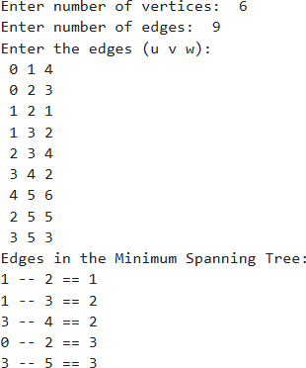

SOURCE CODE:
from collections import defaultdict class Graph:
def init (self):
self.graph = defaultdict(list)

def add_edge(self, u, v): self.graph[u].append(v)

def dfs_util(self, v, visited): visited[v] = True
print(v, end=' ')
for i in self.graph[v]: if not visited[i]:
self.dfs_util(i, visited)

def dfs(self, start_vertex):
max_vertex = max(max(self.graph.keys()), max(max(self.graph.values())))
visited = [False] * (max_vertex + 1) self.dfs_util(start_vertex, visited)

num_vertices = int(input("Enter the number of vertices: ")) g = Graph()

num_edges = int(input("Enter the number of edges: ")) for _ in range(num_edges):
u, v = map(int, input("Enter edge (u v): ").split()) g.add_edge(u, v)

start_vertex = int(input("Enter the starting vertex for DFS: "))

":")
print("Depth First Search (DFS) starting from vertex", start_vertex, g.dfs(start_vertex)

OUTPUT:

